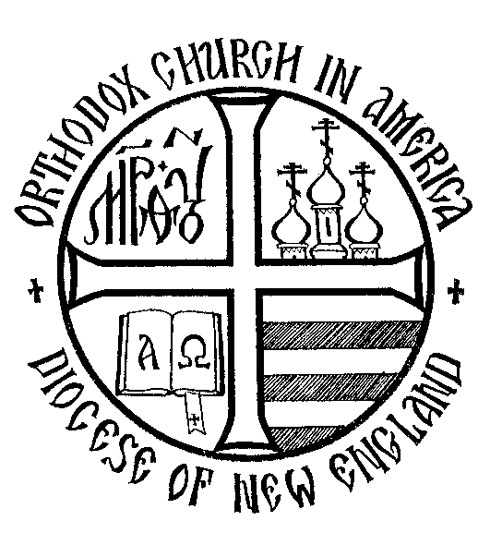

Parish Grant Initiative

Diocese of New England

Orthodox Church in America

# Background Information for Applicants

# Gathering as the Eucharistic assembly in the presence of the Holy Spirit, we are filled with the Body and Blood of Christ and commanded to share what we have received with the world. Emboldened by our collective experience of God, we minister to the world in order to make known God’s mercy, justice, peace and love. Through this revelation of the Church of Christ, the world knows God, the Creator and Redeemer. The goal of all outreach is to draw the world into the net of salvation that is the Church and so, make the world Church. To stimulate outreach during these financially difficult times, the Diocesan Assembly of 2010 approved a resolution to offer small grants to parishes that seek help in carrying forward this saving witness to their respective communities.

# Background

# Overview

The Parish Grant Initiative of the New England Diocese is an opportunity to provide financial support to parishes in the diocese for new or existing parish outreach or charitable projects in their local communities. Modest cash grants will be awarded to a few parishes to help build new programs or to strengthen existing ones.

Many parishes have ideas -- something that the priest or the parish council or a group of parishioners have discussed but they never quite pulled it together. Perhaps lack of funds is a barrier. Perhaps encouragement is needed. The Parish Grant Initiative can, at least in small part, begin to overcome these barriers.

The Parish Grant Initiative can help parishes in the following ways:

* To stimulate discussion on “what more can we do to become a more "visible" and active parish in our community”.
* To stimulate action - Parishes receiving grants will be *required* to act. Progress reports will be displayed on the Diocesan website, in the ONE Newsletter, and a presentation about the project made at the Diocesan Assembly.
* To revive and revitalize outreach - Parishes receiving grants may inspire and stimulate ideas and projects in parishes not receiving grants.
* To bring us closer to each other as a diocese - The Diocese can become engaged in new initiatives that can lead to more support for parishes.

# Grant Process

## 2025 Grants

In 2025, there again will be a maximum of $10,000 available for grants. Target amounts for grants will be $1500 - $2500 per grant but lesser amounts certainly can be requested. Grant applications must include a requested grant amount with details as to how the grant money will be used. The Grant Application is located on the Diocesan website.

## Deadline August 31, 2025

Grants will be awarded by a committee that was appointed by His Grace, Bishop Benedict, and approved by the Diocesan Council. Applications for grants will be accepted until August 31, 2025. Grant Applications are reviewed, and awards are determined upon receipt of the grant application. The names of parishes receiving grants and the projects for which the grants are being awarded will be announced by email and on the Diocesan Website.

## Qualifications of Applicant Parishes

The parish must be in the Diocese of New England, Orthodox Church in America. Grants are given to parishes not persons.

Parishes applying must be up-to-date on all assessment payments.

## Administration of the Grant Program

The grant program is administered and overseen by a committee that has been appointed by His Grace, Bishop Benedict, and approved by the Diocesan Council.

**Parishes receiving grants will be expected to make a presentation at the next Diocesan Assembly about their outreach or charitable project.**

Payment terms (lump sum, quarterly, monthly) will be discussed after selection but should be included in the application.

**Parishes receiving grants must submit a financial summary as to how the grant money was used to support the project including copies of receipts where applicable.**

Grants are to be used for outreach or charitable activities that are or will become part of parish life. A parish can be starting something new or strengthening something already in existence. The grants provide financial incentive to stimulate action and effort on the part of parishes that desire to begin or improve outreach into their communities. Parishes are required to do *real effort* as part of the grant.

Grants will **NOT** be made for facilities improvements or simply to supplement a parish budget.

## Grant Criteria (Application on Diocesan Website)

* A brief description of the proposed outreach program,
* Is this an established program or a new program,
* Community served,
* Need served within the community,
* Mechanics of the plan (preparation, administration, expected results),
* Detailed outline of how the grant money is to be used